Assignment 2: Part 1: ML as a service(b)

Notebook to Cloud:

# Python Performance

### Creating a morphed image based on two input images:

We are given two frames of an animation, Frame 50 and Frame 60

These two frames can be used as example to create Frame 55, which is the in-between of the two input images

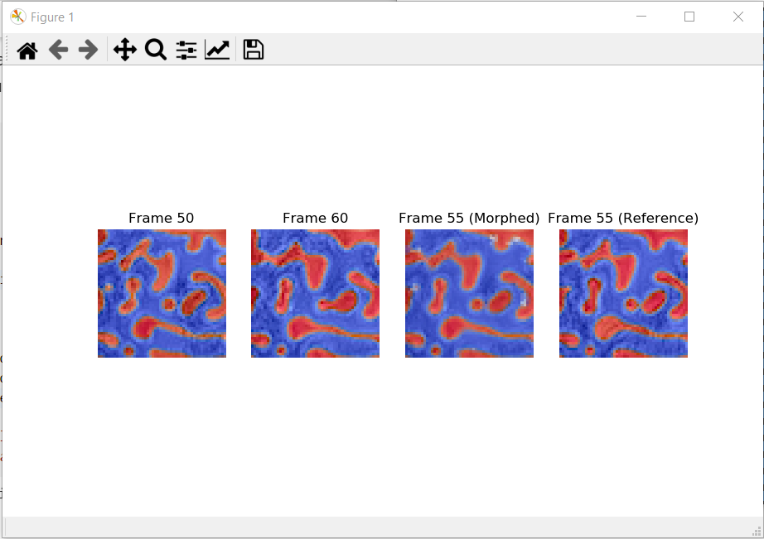

### Regenerative Morph & Regenerative Morph Slow:

To see how the changes in patch_match affects the performance, we compared the difference in runtime and script.

Checked how the runtime of each function has changed.

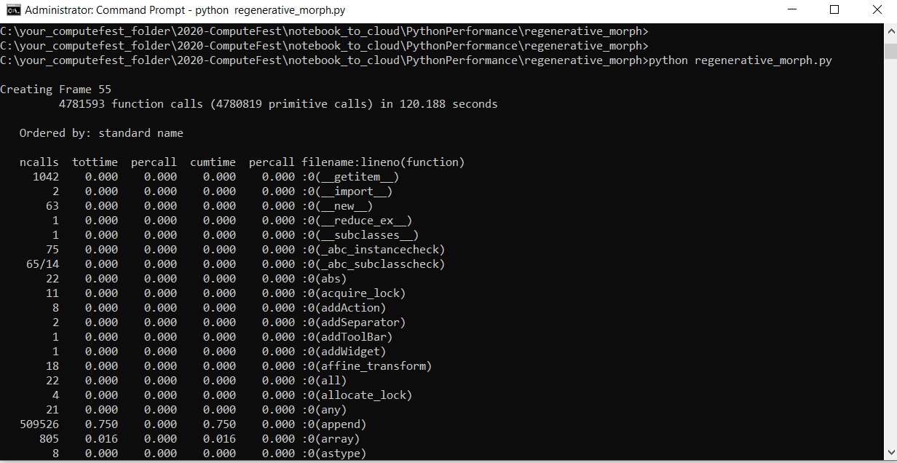

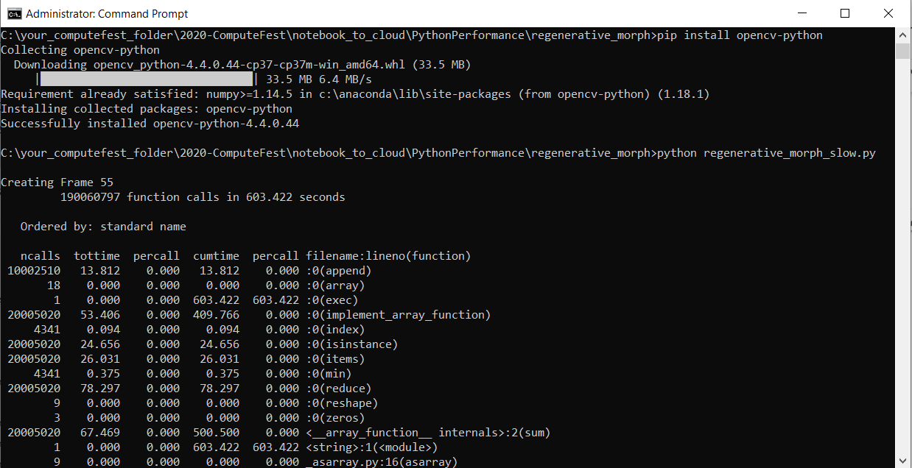

# Serving a model with Docker:

### Serving a model:

Serving a machine learning model means running a server which will accept requests and return model predictions as their response.

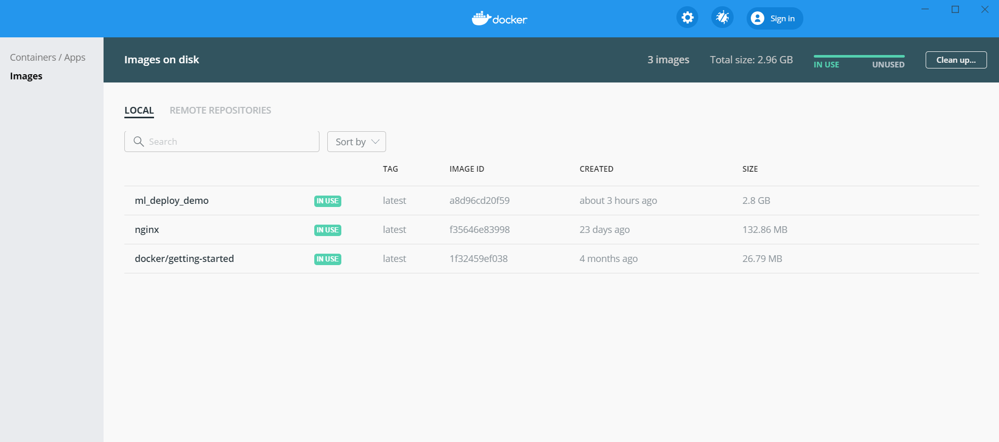

### Sending request to the model with postman:

We were able to send HTTP POST requests and get results back from our model!